Date: 03.02.2023
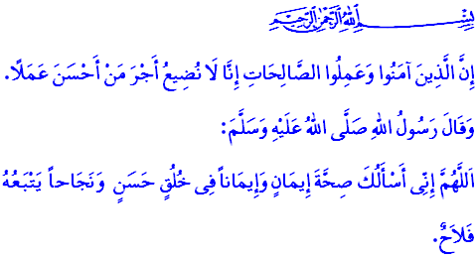
FAITH ENJOINS RIGHTEOUS DEEDS AND GOOD MORALS
Dear Muslims!
Faith is the most fundamental requirement for attaining the pleasure of our Almighty Lord (swt) and eternal salvation. Faith is the wholehearted belief in the existence and oneness of Allah, His prophets, His angels, His books, the Last Day, and that qada (decree) and qadar (destiny) are controlled by Him. It is also one’s sincerity towards their Lord, and their promise of loyalty to Him (swt). Faith is the will to live in peace and security.
Dear Believers!
Righteous deeds are the indicators of faith and its reflection in life. Doing righteous deeds means honoring the covenant of servitude to Allah that we have made out of faith, and to surrender and submit ourselves to Allah with all our being. It is to reflect our faith in our essence, words, and behaviors. It is to live in peace with ourselves, our families, and the people around us. Allah the Almighty (swt) has mentioned faith and righteous deeds together in the Holy Qur’an, and has given the following good news to those who beautify their faith with righteous deeds: “As for those who believe and do good, We certainly never deny the reward of those who are best in deeds.”
Dear Muslims!
What perfects our faith is good morals, which is the most fundamental characteristic of a believer. Good morals are the greatest legacy, after revelations, that prophets leave to their ummahs. Embracing moral virtues and avoiding bad behavior is an indispensable responsibility for the believer. In one of his hadiths, the Messenger of Allah (saw) says, أَكْمَلُ الْمُؤْمِنِينَ إِيمَانًا أَحْسَنُهُمْ خُلُقًا “The most complete of the believers in faith are those with best character among them.”
Dear Believers!
We are the ummah of the Prophet (saw), whom our Lord (swt) has praised by stating, وَاِنَّكَ لَعَلٰى خُلُقٍ عَظ۪يمٍ “And you are truly a man of outstanding character.” and whom He (swt) has sent in order to perfect good character. So, like our beloved Prophet (saw), whose ummah we are honored to be a member of, let us strive to reflect our faith in every aspect of our lives and to embody his sublime morals. The reflection of faith in family life is chastity, kindness, love, compassion, and avoiding hurting and offending each other. The reflection of faith in commercial life is truthfulness and honesty, and to not touch what is not ours, and to pay in full for those who deserve it. The reflection of faith in social life is respect and trust. The reflection of faith in education is to implement the requirements of our knowledge in daily life and to use our knowledge and experience for the benefit of humanity. It is to strive for raising good generations. In short, the reflection of faith in our lives is to observe Allah’s commandments meticulously and to see His (swt) creation through compassion.
Dear Muslims!
Our Lord the Almighty states in the following verse that the believers who will come before Him (swt) with faith and righteous deeds will be greatly rewarded:وَمَنْ يَأْتِه۪ مُؤْمِناً قَدْ عَمِلَ الصَّالِحَاتِ فَاُو۬لٰٓئِكَ لَهُمُ الدَّرَجَاتُ الْعُلٰىۙ “But whoever comes to Him as a believer, having done good, they will have the highest ranks.” So, as we approach Ramadan, let us make these months an occasion for beautiful beginnings. Let us quit our acts that are incompatible with our faith. Let us hold ourselves to account before we pass away from this world. Let us crown our faith with righteous deeds and good morals. Let us not forget that when we are buried in our graves, everyone and everything will be done and gone, and we will be left with only our faith and our deeds.
I would like to conclude this Friday’s khutbah with the following invocation from our Prophet (saw): “O Allah! I ask You to grant me strong faith that is equipped with good deeds, and help me do deeds that will lead me to eternal salvation.”

Kahf, 18/30.
Abu Dawud, Sunnah, 15.
Qalam, 68/4.
Ibn Hanbal, II, 381.
Ta-Ha, 20/75.
Bukhari, Riqaq, 42.
Ibn Hanbal, II, 321. General Directorate of Religious Services

